

DEPARTMENT OF WATER AND SANITATION
REBPUBLIC OF SOUTH AFRICA

REQUEST FOR QUOTATION

REQUEST FOR QUOTATION NUMBER:WQ-32488

DESCRIPTION

SUPPLY AND DELIVER OF CHAIRS AND HEATERS

ISSUE DATE: 20 OCTOBER 2025

CLOSING DATE: 28 OCTOBER 2025

AND TIME: 11:00

EMAIL TENDER DOCUMENT
TO
MPHOHONIN@DWS.GOV.ZA

TENDERER: (Company address and stamp)

COMPILED BY: MPHOHONIN
DEPARTMENT OF WATER AND SANITATION



REQUEST FOR QUOTATION
QUOTATION NUMBER: WQ-32488
DESCRIPTION: SUPPLY AND DELIVER OF CHAIRS AND HEATERS
DEPT CONTACT PERSON: NDIVHUHO
CONTACT NUMBER: 012 336 8135
DATE ISSUED : 20 OCTOBER 2025

QUOTATION RESPONSES MUST SEND VIA EMAIL TO: (indicate email address)
CLOSING DATE FOR QUOTATION (S)
 | DATE | TIME:
 | 28 OCTOBER 2025 | 11:00
No | Item Description | Quantity
1 | High back mesh chairs | 02
2. | Adjustable thermostat convection heater | 1
3. | Bar heater | 1
IMPORTANT INFOMATION
SERVICE PROVIDERS ARE REQUESTED TO ENSURE THE FOLLOWING BEFORE SUBMITTING RESPONSES
- All SBD documents provided with the quotation MUST be fully completed and signed (SBD 1, SBD 4, SBD 6.1 SBD 6.2 (if applicable)
- The signature dates MUST be in line with the current request for quotation.
- All quotations MUST be inclusive of vat (if a supplier is a VAT Vendor).
- All items quoted must be correctly calculated.
- Company’s tax status on CSD MUST be compliant with SARS when submitting a quotation.
- In terms of branded items, the brand name, and the model to be supplied MUST be stipulated in the quotation.
- All quotations must be valid for 60 days.
- Delivery period MUST be indicated on the quotation.
- Late quotations will not be considered.
- Suppliers’ attention is drawn on SBD 6.1 which must be used for claiming points for specific goals. Service providers are advised to use the formula on the Annexure A which provides guidance of how to calculate points to be claimed. Service providers are also encouraged to ensure that the ownership percentages used to calculate claimed points are accurate as these will be used in awarding the quotation as per PPR
- Suppliers are requested to use the quotation number provided as reference on the response email

NB: QUOTATIONS WILL BE AWARDED BASED ON THE HIGHEST SCORE FOR PRICE AND SPECIFIC GOALS COMBINED AND NO LONGER BASED ON THE LOWEST QUOTATION IN LINE WITH THE PPR 2022

SUPPLIERS ARE ADVISED TO REGULARLY CHECK THE DEPARTMENTAL WEBSITE https://www.dws.gov.za/Tenders/Quotations FOR OTHER QUOTATION OPPORTUNITIES THAT MIGHT BE RELEVANT TO THEIR LINE OF BUSINESS

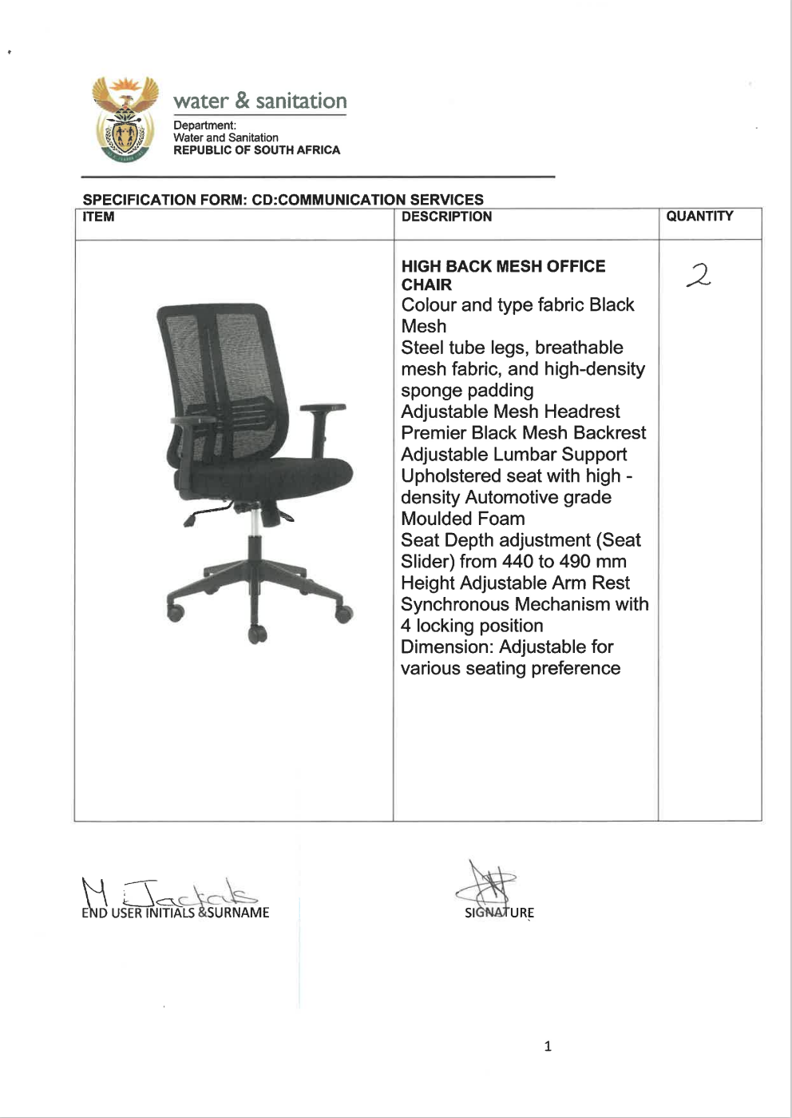
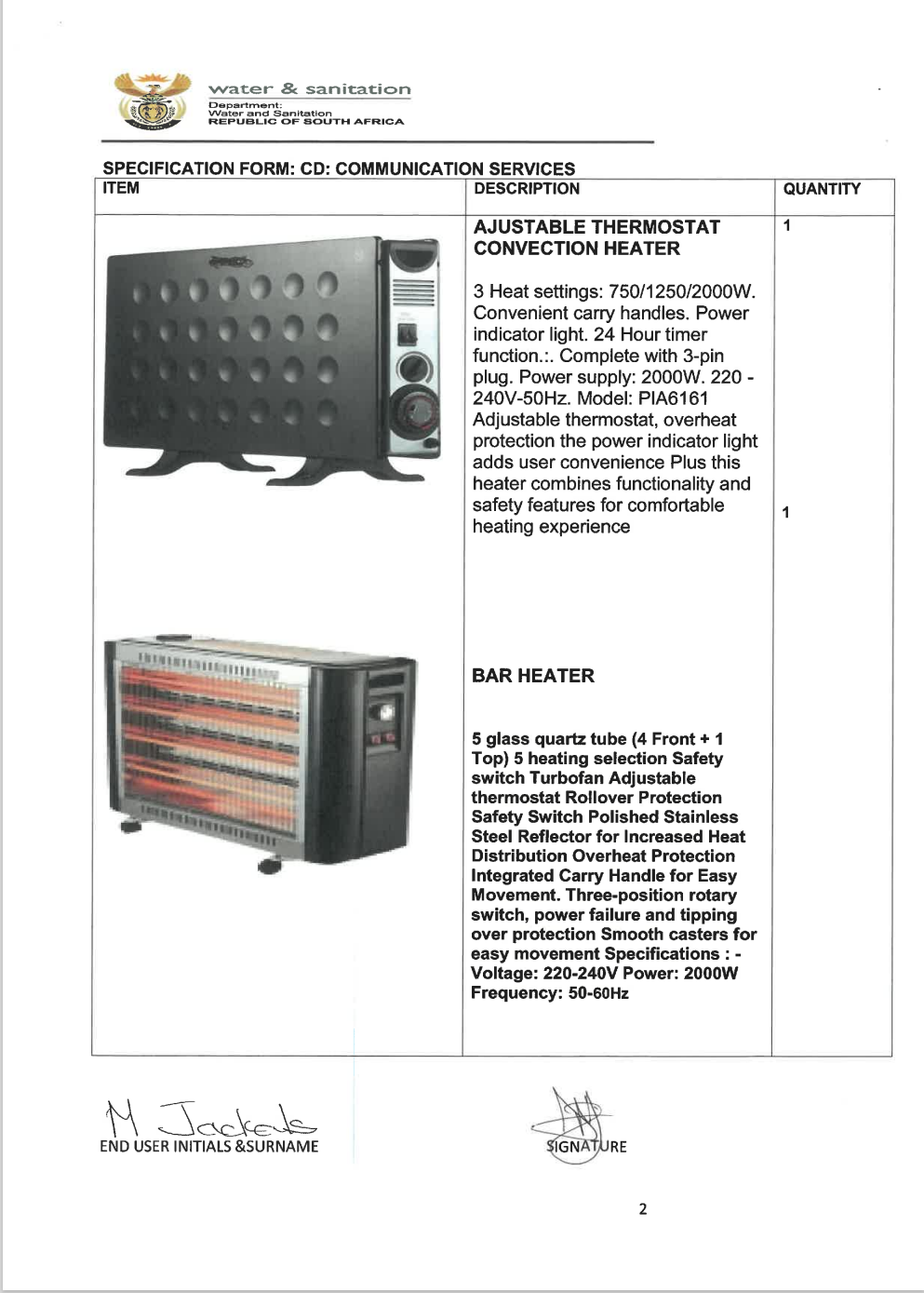

SBD 4

BIDDER’S DISCLOSURE

- PURPOSE OF THE FORM
Any person (natural or juristic) may make an offer or offers in terms of his invitation to bid. In line with the principles of transparency, accountability, impartiality, and ethics as enshrined in the Constitution of the Republic of South Africa and further expressed in various pieces of legislation, it is required for the bidder to make this declaration in respect of the details required hereunder.

Where a person/s are listed in the Register for Tender Defaulters and / or the List of Restricted Suppliers, that person will automatically be disqualified from the bid process.

- Bidder’s declaration
2.1 Is the bidder, or any of its directors / trustees / shareholders / members / partners or any person having a controlling interest in the enterprise,
employed by the state? YES/NO
2.1.1 If so, furnish particulars of the names, individual identity numbers, and, if applicable, state employee numbers of sole proprietor/ directors / trustees / shareholders / members/ partners or any person having a controlling interest in the enterprise, in table below.
Full Name | Identity Number | Name of State institution

2.2 Do you, or any person connected with the bidder, have a relationship with any person who is employed by the procuring institution? YES/NO
2.2.1 If so, furnish particulars:

……………………………………………………………………………………
……………………………………………………………………………………

2.3 Does the bidder or any of its directors / trustees / shareholders / members / partners or any person having a controlling interest in the enterprise have any interest in any other related enterprise whether or not they are bidding for this contract? YES/NO

    - If so, furnish particulars:

Name of company related to | CSD Registration number of the company related to

- DECLARATION

I, the undersigned, (name)……………………………………………………………………. in submitting the accompanying bid, do hereby make the following statements that I certify to be true and complete in every respect:

3.1 I have read and I understand the contents of this disclosure;
3.2 I understand that the accompanying bid will be disqualified if this disclosure is found not to be true and complete in every respect;
3.3 The bidder has arrived at the accompanying bid independently from, and without consultation, communication, agreement or arrangement with any competitor. However, communication between partners in a joint venture or consortium will not be construed as collusive bidding.
3.4 In addition, there have been no consultations, communications, agreements or arrangements with any competitor regarding the quality, quantity, specifications, prices, including methods, factors or formulas used to calculate prices, market allocation, the intention or decision to submit or not to submit the bid, bidding with the intention not to win the bid and conditions or delivery particulars of the products or services to which this bid invitation relates.
3.4 The terms of the accompanying bid have not been, and will not be, disclosed by the bidder, directly or indirectly, to any competitor, prior to the date and time of the official bid opening or of the awarding of the contract.

3.5 There have been no consultations, communications, agreements or arrangements made by the bidder with any official of the procuring institution in relation to this procurement process prior to and during the bidding process except to provide clarification on the bid submitted where so required by the institution; and the bidder was not involved in the drafting of the specifications or terms of reference for this bid.

  - I am aware that, in addition and without prejudice to any other remedy provided to combat any restrictive practices related to bids and contracts, bids that are suspicious will be reported to the Competition Commission for investigation and possible imposition of administrative penalties in terms of section 59 of the Competition Act No 89 of 1998 and or may be reported to the National Prosecuting Authority (NPA) for criminal investigation and or may be restricted from conducting business with the public sector for a period not exceeding ten (10) years in terms of the Prevention and Combating of Corrupt Activities Act No 12 of 2004 or any other applicable legislation.

I CERTIFY THAT THE INFORMATION FURNISHED IN PARAGRAPHS 1, 2 and 3 ABOVE IS CORRECT.
I ACCEPT THAT THE STATE MAY REJECT THE BID OR ACT AGAINST ME IN TERMS OF PARAGRAPH 6 OF PFMA SCM INSTRUCTION 03 OF 2021/22 ON PREVENTING AND COMBATING ABUSE IN THE SUPPLY CHAIN MANAGEMENT SYSTEM SHOULD THIS DECLARATION PROVE TO BE FALSE.

……………………………… ..……………………………………………
Signature Date

……………………………… ………………………………………………
Position Name of bidder

SBD 6.1

PREFERENCE POINTS CLAIM FORM IN TERMS OF THE PREFERENTIAL PROCUREMENT REGULATIONS 2022

This preference form must form part of all tenders invited. It contains general information and serves as a claim form for preference points for specific goals.

NB: BEFORE COMPLETING THIS FORM, TENDERERS MUST STUDY THE GENERAL CONDITIONS, DEFINITIONS AND DIRECTIVES APPLICABLE IN RESPECT OF THE TENDER AND PREFERENTIAL PROCUREMENT REGULATIONS, 2022

- GENERAL CONDITIONS
  - The following preference point systems are applicable to invitations to tender:
- the 80/20 system for requirements with a Rand value of up to R50 000 000 (all applicable taxes included);

  - To be completed by the organ of state
The applicable preference point system for this tender is the 80/20 preference point system.

  - Points for this tender (even in the case of a tender for income-generating contracts) shall be awarded for:
- Price; and
- Specific Goals.

  - To be completed by the organ of state:
The maximum points for this tender are allocated as follows:
 | POINTS
PRICE | 80
SPECIFIC GOALS | 20
Total points for Price and SPECIFIC GOALS | 100

  - Failure on the part of a tenderer to submit proof or documentation required in terms of this tender to claim points for specific goals with the tender, will be interpreted to mean that preference points for specific goals are not claimed.

  - The organ of state reserves the right to require of a tenderer, either before a tender is adjudicated or at any time subsequently, to substantiate any claim in regard to preferences, in any manner required by the organ of state.

- DEFINITIONS
- “tender” means a written offer in the form determined by an organ of state in response to an invitation to provide goods or services through price quotations, competitive tendering process or any other method envisaged in legislation;
- “price” means an amount of money tendered for goods or services, and includes all applicable taxes less all unconditional discounts;
- “rand value” means the total estimated value of a contract in Rand, calculated at the time of bid invitation, and includes all applicable taxes;
- “tender for income-generating contracts” means a written offer in the form determined by an organ of state in response to an invitation for the origination of income-generating contracts through any method envisaged in legislation that will result in a legal agreement between the organ of state and a third party that produces revenue for the organ of state, and includes, but is not limited to, leasing and disposal of assets and concession contracts, excluding direct sales and disposal of assets through public auctions; and
- “the Act” means the Preferential Procurement Policy Framework Act, 2000 (Act No. 5 of 2000).

- FORMULAE FOR PROCUREMENT OF GOODS AND SERVICES

  - POINTS AWARDED FOR PRICE

3.1.1 THE 80/20 OR 90/10 PREFERENCE POINT SYSTEMS
A maximum of 80 or 90 points is allocated for price on the following basis:

80/20 or 90/10

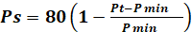 or 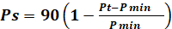
Where
Ps = Points scored for price of tender under consideration
Pt = Price of tender under consideration
Pmin = Price of lowest acceptable tender

  - FORMULAE FOR DISPOSAL OR LEASING OF STATE ASSETS AND INCOME GENERATING PROCUREMENT

    - POINTS AWARDED FOR PRICE

A maximum of 80 or 90 points is allocated for price on the following basis:

80/20 or 90/10

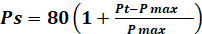 or 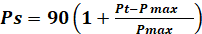

Where
Ps = Points scored for price of tender under consideration
Pt = Price of tender under consideration
Pmax = Price of highest acceptable tender

- POINTS AWARDED FOR SPECIFIC GOALS

  - In terms of Regulation 4(2); 5(2); 6(2) and 7(2) of the Preferential Procurement Regulations, preference points must be awarded for specific goals stated in the tender. For the purposes of this tender the tenderer will be allocated points based on the goals stated in table 1 below as may be supported by proof/ documentation stated in the conditions of this tender:
  - In cases where organs of state intend to use Regulation 3(2) of the Regulations, which states that, if it is unclear whether the 80/20 or 90/10 preference point system applies, an organ of state must, in the tender documents, stipulate in the case of—
- an invitation for tender for income-generating contracts, that either the 80/20 or 90/10 preference point system will apply and that the highest acceptable tender will be used to determine the applicable preference point system; or

- any other invitation for tender, that either the 80/20 or 90/10 preference point system will apply and that the lowest acceptable tender will be used to determine the applicable preference point system,
then the organ of state must indicate the points allocated for specific goals for both the 90/10 and 80/20 preference point system.

Table 1: Specific goals for the tender and points claimed are indicated per the table below.
(Note to organs of state: Where either the 90/10 or 80/20 preference point system is applicable, corresponding points must also be indicated as such.
Note to tenderers: The tenderer must indicate how they claim points for each preference point system.)
The specific goals allocated points in terms of this tender | Number of points  allocated  (80/20 system)  (To be completed by the organ of state) | Number of points claimed (80/20 system)  (To be completed by the tenderer)
Women | 5
People with disability | 5
Youth (35 and below) | 5
Location of enterprise (Province) | 2
B-BBEE status level contributors from level 1 to 2 which are QSE or EME | 3
Total points for SPECIFIC GOALS | 20

DECLARATION WITH REGARD TO COMPANY/FIRM

  - Name of company/firm…………………………………………………………………….
  - Company registration number: …………………………………………………………...
  - TYPE OF COMPANY/ FIRM
Partnership/Joint Venture / Consortium
One-person business/sole propriety
Close corporation
Public Company
Personal Liability Company
(Pty) Limited
Non-Profit Company
State Owned Company
[Tick applicable box]

  - I, the undersigned, who is duly authorised to do so on behalf of the company/firm, certify that the points claimed, based on the specific goals as advised in the tender, qualifies the company/ firm for the preference(s) shown and I acknowledge that:
- The information furnished is true and correct;
- The preference points claimed are in accordance with the General Conditions as indicated in paragraph 1 of this form;
- In the event of a contract being awarded as a result of points claimed as shown in paragraphs 1.4 and 4.2, the contractor may be required to furnish documentary proof to the satisfaction of the organ of state that the claims are correct;
- If the specific goals have been claimed or obtained on a fraudulent basis or any of the conditions of contract have not been fulfilled, the organ of state may, in addition to any other remedy it may have –

  - disqualify the person from the tendering process;
  - recover costs, losses or damages it has incurred or suffered as a result of that person’s conduct;
  - cancel the contract and claim any damages which it has suffered as a result of having to make less favourable arrangements due to such cancellation.
  - recommend that the tenderer or contractor, its shareholders and directors, or only the shareholders and directors who acted on a fraudulent basis, be restricted from obtaining business from any organ of state for a period not exceeding 10 years, after the audi alteram partem (hear the other side) rule has been applied; and
  - forward the matter for criminal prosecution, if deemed necessary.

……………………………………….
SIGNATURE(S) OF TENDERER(S)

SURNAME AND NAME: ……………………………………………………….
DATE: ………………………………………………………
ADDRESS: ………………………………………………………
………………………………………………………
………………………………………………………
………………………………………………………

Annexure A

STANDARD EVALUATION CRITERIA IN TERMS OF THE PREFERENTIAL PROCUTEMENT REGULATIONS 2022

THE 80/20 POINTS AWARDED FOR PRICE AND SPECIFIC GOALS

The 80/20 Preferential Procurement System will be used in evaluating these bids:

Evaluation element | Weighting (Points)
SPECIFIC GOALS | 20
PRICE | 80
Total | 100

Price

A maximum of 80 points are allocated for price on the following basis:

⎟
⎠
⎞
⎜
⎝
⎛
−
−
=
min
min
1
80
P
P
Pt
Ps
Where:
Ps = Points scored for comparative price of bid under consideration
Pt = Comparative price of bid under consideration
Pmin = Comparative price of lowest acceptable bid

Preference point system

SPECIFIC GOALS | NUMBER OF POINTS TO BE ALLOCATED
Women | 5
People with disability | 5
Youth (35 and below) | 5
Location of enterprise (Province) | 2
B-BBEE status level contributors from level 1 to 2 which are QSE or EME | 3
Total points for SPECIFIC GOALS | 20

- Documents Requirement for verification of Points allocation: -
Procurement Requirement | Required Proof Documents
Women | Full CSD Report
Disability | Full CSD Report
Youth | Full CSD Report
Location | Full CSD Report
B-BBEE status level contributors from level 1 to 2 which are QSE or EME | Valid BBBEE certificate/sworn affidavit  Consolidated BEE certificate in cases of Joint Venture  Full CSD Report
The definition and measurement of the goals above is as follows:

                - Women, disability, and youth:

                - This will be measured by calculating the pro-rata percentage of ownership of the bidding company which meets this criterion. E.g., Company A has five shareholders each of whom own 20% of the company. Three of the five shareholders meet the criterion, i.e. they are women/disability/youth. Therefore, this bidder will obtain 60% of the points allowable for this goal.

Location of enterprise

Local equals province. Where a project cuts across more than one province, the bidder may be located in any of the relevant provinces to obtain the points.

B-BBEE status level contributors from level 1 to 2 which are QSE or EME

Measured in terms of normal BBBEE requirements.

Note: Formula for calculating points for specific goals

Preference points for entities are calculated on their percentage shareholding in a business, provided that they are actively involved in and exercise control over the enterprise. The following formula is prescribed:

PC= Mpa x P-own
100
Where

PC= Points awarded for specific goal

Mpa= The maximum number of points awarded for ownership in that specific category

P-own = The percentage of equity ownership by the enterprise or business

the power, by one person or a group of persons holding the majority of the equity of an enterprise, alternatively, the person/s having the deciding vote or power to influence or to direct the course and decisions of the enterprise.
Joint venture or Consortium means an association of persons for the purpose of combining their expertise, property, capital, efforts, skill and knowledge in an activity for the execution of a contract.

